Empowering Adaptive Lectures via Activation of Intelligent and Web 2.0 Technologies
ABSTRACT
Different Learning Paradigms can be presented by different educators as a result of utilizing several types of Information and Communication Technologies in the Learning Process. The three abstract Learning Delivery Models are: Traditional, Distance, and Hybrid Learning. Hybrid Learning attempts to maintain the best of Traditional Learning and provides the hopes and objectives of Distance Learning in a model that maintains the “Learning Process” on the right road. Hybrid Learning shall be making use of different technologies available, exactly as does Distance Learning. Research that has focused on adopting Intelligent Technologies in Classrooms is not widely presented and deployed. Besides, the widespread of Web 2.0 resulted in the appearance of the acronym (e-Learning 2.0). e-Learning 2.0 is supposed to make use of different Web 2.0 capabilities. Web 2.0 is a big resource that changed the way everyone around thinks about and accesses the Internet, and greatly will touch the coming generations; the generations that we are currently presenting education to.

This paper presents a proposed pedagogical and technical framework to empower classroom lectures with intelligent and Web 2.0 technologies that hopefully will enhance the learning process in learning institutions. Adaptive Lecture as a concept tends to help instructors providing more personalized lectures via utilizing Intelligent and Web 2.0 technologies. The growing number of students that is hardly met by growing number of instructors is a challenge. In order not to make this challenge affects the performance of the lecture, utilizing Web 2.0 technologies in the “formative assessments” within classroom becomes important. Besides, in order to powerfully reach students, data about those students shall be gathered and further analyzed to make them feel more “Lecture Personalization” and get “involved” deeply with the lecture activities. Intelligent features can play an important role in achieving this task.
Keywords: Lecture, Adaptive Lecture, University Architecture, IT Infrastructure, Before-Lecture, In-Lecture, After-Lecture
1. INTRODUCTION
E-learning 2.0 has lighted a new torch over processes and roles in acquiring knowledge. A heterogeneous community of teachers and learners can dialectically share and improve their knowledge, lit up by Web 2.0 facilities and massive multimedia employment. This trend has a particularly strong impact on e-learning, finally offering new tools and methodologies to effectively work as in an on line community of practice, articulated and promoted by people. The traditional way pursued by e-learning has been overcome by the wide use of Web 2.0 applications, from blog to podcast, from wiki to media sharing. From the accessibility point of view, e-learning 2.0 and its related novel Internet technologies represent a pitfall challenge (Ferretti et al., 2008).
This paper presents the pedagogical and technical models of "Adaptive Lecture". Adaptive Lecture as a concept tends to help instructors providing more personalized lectures via utilizing Intelligent and Web 2.0 technologies. In order to achieve "Adaptive Lecture", students need access to different online resources during the lecture immediately, either via her/his cell / smart phone and Tablet/Mobile PC. Instructor can assign tasks to students, and they immediately switch to their mobile computing devices and start working on them. Instructor can share the presentation from her/his laptop with the whole class that is connected via wireless connection. Instructors are not just giving students information and defining assignments, but they go beyond recalling information to ensure that students can retrieve the information, understand, apply the information to become "knowledge".

1.1 CURRENT LECTURE MODEL “PROBLEM DEFINITION”
Current lecture model; that exists for a while right now entitles that: Students go to classroom, where there is teaching stuff presenting lectures, and defining assignments, defining sections, and labs to be followed by teaching assistants later. This model used to work fine when the number of students used to exceed by more than hundreds the number of professors, but questions about the efficiency and effectiveness of this model has arose to the surface lately. This system, is too much stable: students know the courses they are going to attend, they have question banks, and all that academic stuff available today. This system has stabilized to the extent that it kills innovation and prevents students and professors from really: Learning. One of the reasons that affect this model’s efficiency is the lack of connection and weakness of communication between students and instructors. With this huge number of students, there are doubts about the instructor's capability to connect with everyone sitting in front of her/him. Of course this is a matter that differs with experience and varies from instructor to another; however it is still a matter to question.
This lecture model might be acceptable in countries with acceptable student-teacher ratio. However, based on the Arab Knowledge Report (2009), higher education in the Arab region suffers a considerable shortage of teachers. In 2005, the student-teacher ratio was 25:1, compared to the global average of 16:1. The Arab student-teacher ratio is the highest among all regions of the world, including sub-Saharan Africa. The shortage is more severe in some countries than in others. The student-teacher ratio is at least double the global average in Yemen, Egypt, Algeria, and Palestine, and one-and-a-half times the global average in Jordan, Bahrain, Mauritania, Libya, the UAE, and Saudi Arabia. Hopefully proposed adaptive lecture model will enhance the lecture learning experience and might help to overcome such a challenge; especially in Arab region.
Even in countries with acceptable student-teacher ratio, the current lecture model doesn’t entitle students to feel a real utilization of new technologies in the learning process. The 2009 21-st Century Campus Report (2009) presents some facts that are important in imaging the current situation, and hopefully will be leading the move to the new model. One of the facts is the existence of different views between instructors and students rate for utilizing technology. Instructors rate their use and understanding of technology as high, but students disagree with that assessment. Students rate faculty lack of tech knowledge as the biggest obstacle to classroom technology integration and see it as a growing problem.
1.2 PROPOSED ADAPTIVE LECTURE MODEL “OBJECTIVES”
Adaptive Lecture is the lecture where the lecture supports one or more forms of adaptivity via utilizing one/more of Intelligent and Web 2.0 technologies. Adaptivity features are many, and include (not only):
- Table of Contents / List of Lecture Topics
- Contents, Learning Materials, and Presentations
- Order of Topics and Contents
- Time Required for learning a topic
- Assessments’ Types
Proposed adaptive lecture focuses on the “Engineering” of the “Lecture” and moving it from the static model that it used to be on right now, to the dynamic and engineered model. “Engineering” of the “Lecture” aims to provide instructors and learning institutions process-focused methods for improving lecture efficiency and as a result, the learning quality. Presenting learning activities within lectures in terms of processes helps identifying points of strengths and weaknesses in lecture model, modifying these processes based on needs and requirements, and managing these processes via Learning Process Management Systems, thus providing a continous improvement lecture lifecycle.
The rest of this paper goes as follows: Section two compares between current lecture model and proposed adaptive lecture model highlighting the main shortages of current model. Section three presents the educational institutions technologies convergence from traditional to Web 2.0 technologies. Section four presents the proposed university architecture from four different dimensions: Business, Software, Information, and IT Infrastructure to support proposed adaptive lecture model. Section five highlights the instructor’s challenges presented by such a model and expected outcome from adopting this model. Section six concludes the paper.
2. CURRENT LECTURE MODEL VS. PROPOSED ADAPTIVE LECTURE MODEL
Adaptive Lecture is the hype of Tutoring and Current Lecture Model empowered by Intelligent and Web 2.0 technologies. Tutoring is always the best solution to provide learning; however it is hard to afford tutoring to the increasing number of students. Table 1 presents a comparison between the Current Lecture Model and Proposed Adaptive Lecture Model based on the adaptivity features presented in section 1.2.

Table 1: Comparison between Current Lecture Model and Proposed Adaptive Model features
 | Current Lecture Model | Proposed Adaptive Lecture Model
List of Lecture Topics | Static | Variable
Contents, Learning Materials, Presentations | Static | Variable
Order of Topics and Contents | Static, Predefined | Varies
Time Required for a Topic | Static, Predefined | Varies
Assessments | Predefined | Varies

2.1 LECTURE TOPICS
In Current Lecture Model, list of topics within the lecture is already predefined by instructor. Students are supposed to be satisfying course prerequisites before attempting current course, so instructors might not pay much attention to different students needs. This is not the case with adaptive lecture model because instructor can get a detailed view of students’ learning profiles and intelligent analysis and recommendations based on those profiles while preparing the lecture, and is easily connected with students and capable of determining either it is accepted to move on with the predefined list of topics, or take sometime to present some of the prerequisites upon need before discussing the main lecture topics.
2.2 CONTENTS, LEARNING MATERIALS, AND PRESENTATIONS
Contents, Learning Materials, and Presentations to be presented during the lecture also shall vary based on what students have learned before, and based on their backgrounds. One of the most taken for granted assumptions is that "Students prefer animation and videos in learning". There are situations where students face problems with understanding what they watch in the videos. It is clear that most of the videos are not created and edited by the instructor, so s/he has to display it the way it is. This situation took place during teaching Computer Networks course for example. After students watched the famous "Warriors of the Net: The Movie" available at http://www.warriorsofthe.net/movie.html, they became confused about many of the concepts they have been kept told about during the lecture before watching the video. Some students loose concentration during video presentations, and they just spend the time relaxing till the instructor starts talking again.
2.3 ORDER OF TOPICS AND CONTENTS
Order of Topics to be presented in the Lecture is mainly an instructor's responsibility. Doubts about the students' ability to define the order of topics to learn during a lecture; especially if all the proposed topics are new to them are clear. However, students can easily define the order of contents displayed to them. Personal differences and out of control surrounding circumstances might drive the lecture in different paths. For example, if the lecture includes a presentation and a video file, there are different scenarios for driving the lecture:
- Watch the Video and then illustrate and start discussions with students
- Illustrate the video and take feedback from students, conclude the discussion with the video
- Introduce a brief about the video contents, watch the video, and ten talk about it
- Begin watching the video immediately, illustrate and talk about it, conclude the discussion by watching it for a second time
There is no best choice of course. However, there is an optimal solution based on different inputs like, time, projector availability, lightning in case projector display is affected by the high sunlight at the beginning of the lecture so delaying the video to the end of the lecture might overcome this challenge, and other factors. The question is: Why don't add Students themselves as an input factor of the issue ?
2.4 TIME REQUIRED FOR THE LECTURE
Bloom (1984) showed twenty-five years ago, as reported in his 2 sigma paper, that almost all students can learn to the mastery level, given the right learning environment (Bloom ,1984; Moursund, 2005). One of the important factors of the abovementioned right learning environment is the "Time Factor". Bloom showed that all students reached mastery level for certain topics after different time intervals of learning. Thus, assuming that learning Topic A for example will take Time A period might be not acceptable assumption in some cases and for some students. Instructor's experience in topics and with teaching students helps a lot of course in defining such confusing issues, however as we are in the dawn of Web 2.0, why not start using Web 2.0 capabilities in e-Learning ?
2.5 ASSESSMENTS
Assessment is an integral part of learning, guiding the process and stimulating further learning. Conducting Assessments is an important learning activity that tends to estimate and measure students’ understandings of taught topics. Assessments shall go beyond such testing students’ ability of recalling data from their short/long memory to verifying students’ abilities to use the gained knowledge in an efficient manner; so they become knowledgeable about the learned topics. Bloom’s taxonomy addresses this issue in detail (Krathwohl, 2002). Assessment Approaches are (Earl, 2003): Assessment of Learning, Assessment for Learning, and Assessment as Learning.

- Assessment of Learning (summative): it is the predominant kind of assessment. Its purpose is summative, intended to certify learning and report about students’ progress. It is typically done at the end of a unit, a course, or a grade. It takes the form of tests or exams that include questions drawn from the material studied during that time. Results are expressed symbolically, generally as marks or letter grades.
- Assessment for Learning (formative): it focuses on the gap between current learner orientation of the learning process and the desired goal of learning. Assessment for learning can be defined as activities undertaken by teachers and/or their students, which provide information to be used as feedback to modify the teaching and learning activities in which they are engaged (Black and William, 1998). Learners learn best when they understand what they are trying to learn, what is expected of them, given feedback about the quality of their work and what they can do to make it better, given advice about how to go about making improvements, fully involved in deciding what needs to be done next, and who can give them help if they need it (Ellis, 2001).
- Assessment as Learning: This is part of the cycle of assessment where learners and instructors set learning goals, share learning intentions and success criteria, and evaluate their learning through dialogue and self and peer assessment (Henderson, 2003).
A balanced assessment system takes advantage of assessment of learning and assessment for learning; each can make essential contributions. When both are presented in the system, assessment becomes more than just an index of learning institution success. It also serves as the cause of that success (Chappuis, 2004). Instructors might need to conduct one of the on-the-fly formative assessments to ensure that students have reached a basic level of knowledge regarding one of the topics before moving to the next one. That next topic might rely heavily on the pre-topic; understanding next topic is based on understanding the first one. Those assessments are of no importance while grading students; in most cases instructors don’t count the speed of understanding topics in grades, however it is still an option if instructors are interested. Such type of assessments is made feasible via proposed Adaptive Lecture Model.
Different types of questions shall be asked to different students. Not all students share the same learning characteristics. Defining different students’ learning models is important in providing them the most suitable type of questions. Variety between types is required of course, and it can be used to encourage students to think in a different way. However, most e-Learning systems support MCQs, T/F Questions; because of their ease of management and implementation. Most of students complain about their inefficiency to answer those types of questions. This case is not just a case of “Technology limiting e-Learning”. Web 2.0 has presented different technologies that can be utilized in providing different and innovative types of assessments. To be able to do so, analysis of students’ learning model is needed. Intelligent technologies can be used to collect students’ data, build learning profiles, analyze, classify / cluster students into different classes/clusters, and deliver personalized learning environment.
3. LEARNING INSTITUTION TECHNOLOGIES CONVERGENCE FROM CLASSICAL TO WEB 2.0
Using ICT in learning has a long history, and diverse variety of concept, theory, proof, adoption, implementation, evaluation, and validation. ICT utilization in learning was handled in different ways and from different points of views over the years. Different ICT presented in learning include: Adaptive Teaching System, Assessment Management System, Authoring System, CAI: Computer Assisted Instruction, CAPA: Computer Assisted Personalized Approach, CBT: Computer-Based Training, CIT: Computer-Information-Television, Collaborative Learning, Computer Managed Learning System, Computer Assisted Learning, Course Management System, Courseware Authoring Tool, Distance Education, Electronic Courses, Enterprise Course Management System, Online Courses, Integrated Student Information System, LCMS: Learning Content Management Systems, LMS: Learning Management System, Interactive Learning Environment, Integrated Learning System, PLE: Personal Learning Environment, Telecast, Virtual College, Virtual Conference, Virtual Classroom, Virtual University, VLE: Virtual Learning Environment, WBT: Web Based Training, Web-based Interactive Course.
3.1 CURRENT WIDELY SPREAD TECHNOLOGIES IN LEARNING INSTITUTIONS
Utilizing ICT in universities can be categorized mainly under two categories: University Management Information Systems (UMISs), and Learning Management Systems (LMSs). A comparison between systems’ components, scopes, interest, usage, features, and utilization in universities yields that (El-Ghareeb, 2009):
- UMIS: used in handling and managing Managerial aspects of the university. They have almost nothing to do with the pedagogical process. However, their existence is almost a must. UMIS exceeds LMS by decades, and has reached a stable levels of well-defined requirements, existence, acceptance, implementation, and performance levels. UMIS include different sub information systems that work to facilitate and manage the activities of different departments of the university as an organization. Examples of those sub information systems are: Student Information System (SIS), Library Information System, Faculty Information System, and Finance System.
- LMS: used in handling and managing the learning process. LMS implements technologies that enable virtual/digital university, and/or personal learning environments. LMS features can be categorized into four sub systems which are concerned with courses, exams, assessments, and collaborative features. LMS can be thought of as the integration of four sub systems; each presenting specific functionalities via specific tools.
Both UMIS and LMS have to integrate and operate together to support educational institutions and e-Learning. One of the international initiatives that provide information to institutions on investing in and using information technology infrastructure is e-framework "http://www.e-framework.org". The e-Framework for Education and Research has been established to help the education and research arenas take advantage of the opportunities offered by the service-oriented approach.
3.2 WEB 2.0 TECHNOLOGIES
Ever since group behavior became an important part of mainstream Web sites, companies have found numerous ways to exploit the behavior of Web surfers. Simple uses of Web 2.0 ideas include businesses like Amazon.com soliciting product rankings from consumers and offering shoppers hints of what others have bought. More overt notions of Web 2.0 include the many social networking Web sites that have tried to profit from the basic human need to connect with others. Facebook, MySpace, Friendster, Tribe, LinkedIn, Spoke, and countless others have looked to profit on connecting teens, communities, professionals, and just about any other type of demographic. The Web 2.0 phenomenon is more rightly described as a social and behavioral sea change. Instead of serving up static fixed content to Web surfers, the Web has become an interactive place for people to congregate and do things together virtually. Web 2.0 is about the way people use Web 1.0, not about the Web itself (Pollock, 2009). Web 2.0 refers to the social use of the Web which allow people to collaborate, to get actively involved in creating content, to generate knowledge and to share information online (Grosseck, 2009). Most instructors are fascinated with teaching and learning, so they are interested in utilizing whatever their hands reach to in enhancing and supporting the learning process. Instructors are surrounded by acronyms that are completely new to them, and there is not enough time to get used to one of the technologies before another becomes available. Different utilization of Web 2.0 technologies in learning institutions and in the learning process have been presented and evaluated. However, this utilization is still in its first hype, and different innovative utilization will become available. Figure 1 presents one of the Web 2.0 utilization in e-Learning taxonomies presented by El-Ghareeb (2010). Detailed information about different Web 2.0 technologies, Web 2.0 utilization in real-life scenarios, in practice, theory, and evaluation are presented (El-Ghareeb, 2010).

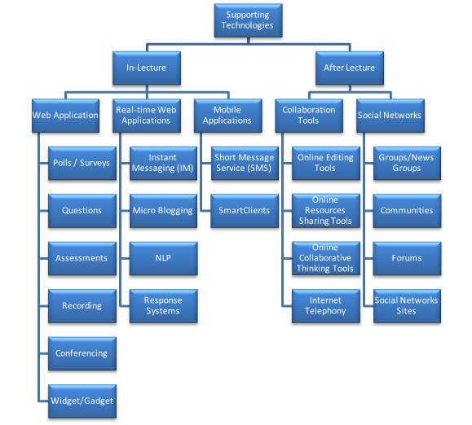
Figure 1: Web 2.0 Technologies in e-Learning Taxonomy. Source: El-Ghareeb (2010)
4. PROPOSED UNIVERSITY ARCHITECTURE TO SUPPORT PROPOSED ADAPTIVE LECTURE MODEL
In Proposed Adaptive Lecture Model, Enterprise is the University, thus “Enterprise Architecture” and “University Architecture” are used interchangeably to refer to the same concept. Enterprise architecture tends to define the enterprise from the four dimensions in order to connect between them and present a complete view for the enterprise environment to face the ubiquitous challenges. It has become accepted that there is a clear need for an ‘architectural view’ of systems (Macaulay, 2004). The architectural view of systems (both business and IT systems) is defined in ANSI/IEEE standard 1471-2000 as “the fundamental organization of a system, embodied in its components, their relationships to each other and the environment, and the principles governing its design and evolution”. Enterprises can be thought of as the combination of business needs, and IT capabilities. Different dimensions of the enterprise need to be defined in order to generate the enterprise architecture. From enterprise point of view, architectures are classified into four categories (Albin, 2003): Business Architecture, Software “Application” Architecture, Information Technology (IT) Architecture, and Information Architecture as depicted in figure 2.Enterprise Architecture classes utilize each other, and build over each other. Distinctions between classes are blurred because they all serve each other, and serve the enterprise.
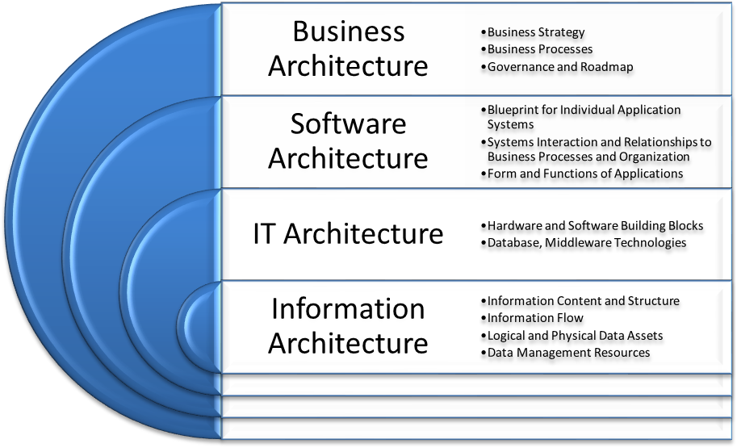
Figure 2: Enterprise Architecture Dimensions and Roles

Proposed Adaptive Lecture Model requires certain amount of Enterprise Agility that is provided by utilizing Service Oriented Architecture (SOA) within the four Enterprise Dimensions. Utilizing SOA provides Educational Institution's with both Business and Technical Agility perspectives. Business agility means fast reaction to change and the ability to rapidly implement changes. Business agility needs to be holistic in scope (Evans, 2001). Technical agility refers to the ability to quickly change the type and flow of information within an organization within enterprise. SOA as a design pattern presents Applications, IT infrastructure and Information Architectures as loosely coupled, fine granular services that can address enterprises’ requirements once they are addressed either by adding new services or modifying existing ones. SOA also addresses Enterprises Information Systems’ inefficiency by enhancing reusability, thus theoretically, shortening information systems development time and effort required. SOA addresses technical agility requirements by presenting composability, modularity, and loose coupling concepts as services that wrap underlying IT infrastructure, databases, and legacy systems and present them via standard interface. There is a need to stabilize IT infrastructure rather than developing new ones (Baskerville, 2005) and SOA enables this stabilization. Enterprises should balance IT to become better positioned and more agile (Leidner et al., 2003). Services are the building Blocks of an agile enterprise (Pal and Pantaleo, 2005). W3C defines Service as “A Component capable of performing a task”. Service is “A vehicle by which a consumer’s need or want is satisfied according to a negotiated contract (implied or explicit) which includes Service Agreement, Function Offered and so on”. SOA is the design pattern that utilizes services concept to achieve architectural advantages. W3C defines SOA as “A set of components which can be invoked, and whose interface descriptions can be published and discovered”. This definition can be expanded to include the science, art and practice of building applications (Sprott and Wilkes, 2004). SOA is defined as “The policies, practices, frameworks that enable application functionality to be provided and consumed as sets of services published at a granularity relevant to the service consumer. Services can be invoked, published and discovered, and are abstracted away from the implementation using a single, standards based form of interface”.
4.1 BUSINESS ARCHITECTURE TO SUPPORT PROPOSED ADAPTIVE LECTURE MODEL
A business or business process architecture defines the business strategy, governance, organization, and key business processes within an enterprise. The fields of Business Process Reengineering (BPR) and Business Process Management (BPM) focus on the analysis and design of business processes, not necessarily represented in an IT system (Albin, 2003). Business Architecture defines the business roadmap usually via defining the business processes (Bechara, 2006). Business process is a series of inter-related activities that cross functional enterprise boundaries with individual inputs and outputs (May, 2003; de Putte et al., 2004). New Business Processes need to be defined to cope with the new educational requirements presented in today's educational institutions. Years ago, a concept like proposed adaptive lecture would be far away from reality. Nowadays, professors and instructors in educational institutions are forced to shake the stagnant water of traditional practices during lectures that lead to students' loss of interest in lectures, and probably in the traditional learning overall. BPM is a systematic, structured approach to analyze, improve, control, and manage processes (Chang, 2005). BPM needs to be adopted within universities to enhance both managerial and educational aspects of educational institutions. BPM need to address pedagogical and learning processes as it addresses managerial aspects. Proposed Adaptive Lecture Model can be further studied as a Business Process, and managed by educational institution's Business Process Management System (BPMS). BPMS is an enterprise information system that supports designing, administrating, and improving the business processes (Ha, 2005).
4.1.1 PROPOSED ADAPTIVE LECTURE MODEL AS BUSINESS PROCESSES
Proposed Adaptive Lecture Model constitutes three different phases: Before-Lecture, In-Lecture and After-Lecture. Both features need to be further studied by educational institutions to define the most suitable scenarios to be implementing and deployed. Business Process Modeling Notation (BPMN) is one of the standards widely used to present business processes. Figure 3 presents one of the activities that take place in the “Before-Lecture” phase; that is: Preparing the Lecture Materials. Students' learning models are not the same, and that shall be considered while preparing and choosing the contents to be displayed during Lecture. In order not to lose student during the lecture, types of contents shall be mapped with both their direct feedback and learning profiles. Figure 3 presents the different activities required to fulfill this process.
Figure 4 presents one of the In-Lecture activities of the proposed adaptive lecture model; that is reshaping the lecture based on students’ indirect feedback via Web 2.0 technologies. In proposed model, different activities performed by instructor and student are highlighted in different lanes, besides the necessity for a Real time Application that performs the analysis tasks on students feedback. In this business process, reshaping lectures is a smooth activity that might take place without students’ notifications of the process happened.

Further tasks to that business process can include the instructor’s invocation of an overall feedback on the lecture. Thus, LMS needs to define the different utilized methods that students’ uses to access the LMS, the preferences stored for them to submit the quiz. Figure 5 illustrates the sequence of activities that takes place when instructor initiates such a process. Figure 5 starts from the end point of figure 4, and continues.
Figure 6 presents the required tasks that take place to identify two important After-Lecture activities: Provide students with the materials and recordings of the current lecture, and identify students’ familiarity with next lecture topics. Proposed Adaptive Lecture Model can access the Students’ Profiles and Preferences for data about their previous attended sessions, courses, specifications, and other details. In case one of the students doesn't satisfy requirements defined by instructor, a personalized content can be generated for that student via Intelligent Learning Objects (LOs) Recommender, and Student's interaction with those materials is tracked. Figure 3 presents one of the After-Lecture activities and the different system’s activities to support the adaptive LOs recommendation.

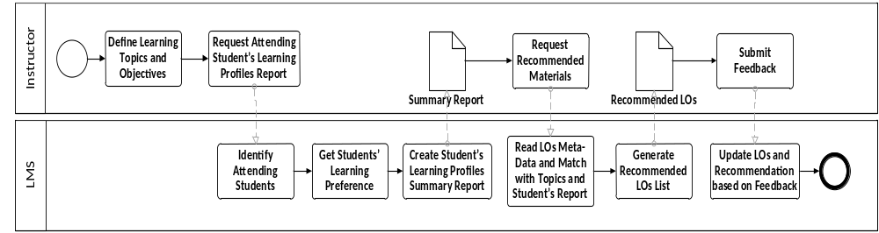
Figure 3: Recommend LOs for Instructor based on Analysis of Learning Profiles Process

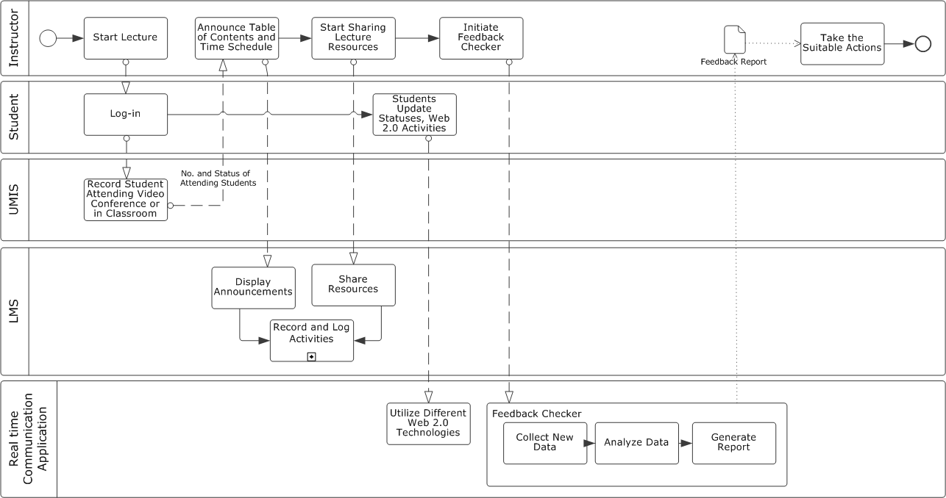
Figure 4: Proposed In-Lecture Informal Feedback activity feature of the Proposed Adaptive Lecture
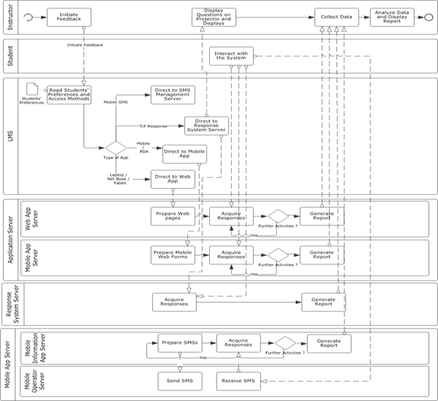
Figure 5: Proposed Formal In-Lecture Feedback Process of Proposed Adaptive Lecture Model

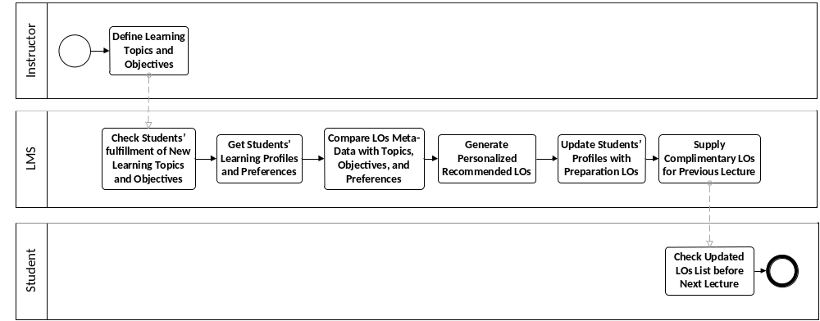
Figure 6: Recommend LOs for Students based on Upcoming Lecture Topics and their Preferences

4.1.2 PHILOSOPHY, OBJECTIVES, AND STRATEGIES TO SUPPORT PROPOSED ADAPTIVE LECTURE MODEL
Philosophy behind proposed Adaptive Lecture Model is the attempt to enhance the learning process and elevate the learning qualities within classrooms via utilizing modern and innovative technologies that are widely spread among students. Objectives are simply to present an educated and well informed learner that is capable of facing new daily presented challenges. Learners can estimate the value of technology when they use it daily in their learning process, so they become aware of them. Different strategies shall be defined and maintained; either by Top-Level Management or by instructors themselves to innovate the learning process. Many aspects of innovative technologies discussed in section three are facilitated and made available online via different implementations. Those services shall be used to support e-Learning in an innovative manner. Strategies include:
- Utilizing Different Technologies Available Right now
- Developing the proper IT infrastructure to support Adaptive Lecture Model (wireless networks, servers, etc.)
- Providing Students with appropriate access devices (laptops, Net Books, PDAs, etc.)
- Defining the Collaboration plans with third parties to accelerate the movement, and identifying what to develop and maintain in-house.
- Evaluating different system architecture approaches to achieve required goals. One of the design approaches presented in this paper is SOA, however it is not the only one.
- Defining differences clearly between applications and each one responsibility, making sure that e-Learning that is pedagogically implemented and maintained goes further beyond just University Management Information Systems.
4.2 SOFTWARE ARCHITECTURE TO SUPPORT PROPOSED ADAPTIVE LECTURE MODEL
Software / Application architecture serves as the blueprint for individual application systems, their interactions, and their relationships to the business processes of the organization. A software application is a computer program or set of programs that uses existing technologies to solve some end-user problem such as the automation of an existing business process. Software architecture can be defined as “the sum of the nontrivial modules, processes, and data of the system, their structure and exact relationships to each other, how they can be and are expected to be extended and modified, and on which technologies they depend, from which one can deduce the exact capabilities and flexibilities of the system, and from which one can form a plan for the implementation or modification of the system” (Hohmann, 2003). Application Architecture defines the form and function of the applications that will be developed to deliver the required functionality of the system (Macaulay, 2004). Integrating current University Management Information Systems (UMISs) that include different components like Student Information Systems (SISs), Library Information Systems, Financial Systems, and other components with the implemented Learning Management Systems (LMSs) has been a challenge that facing educational institutions for a while. Figure 7 presents the required software architecture to support proposed adaptive online lecture model.

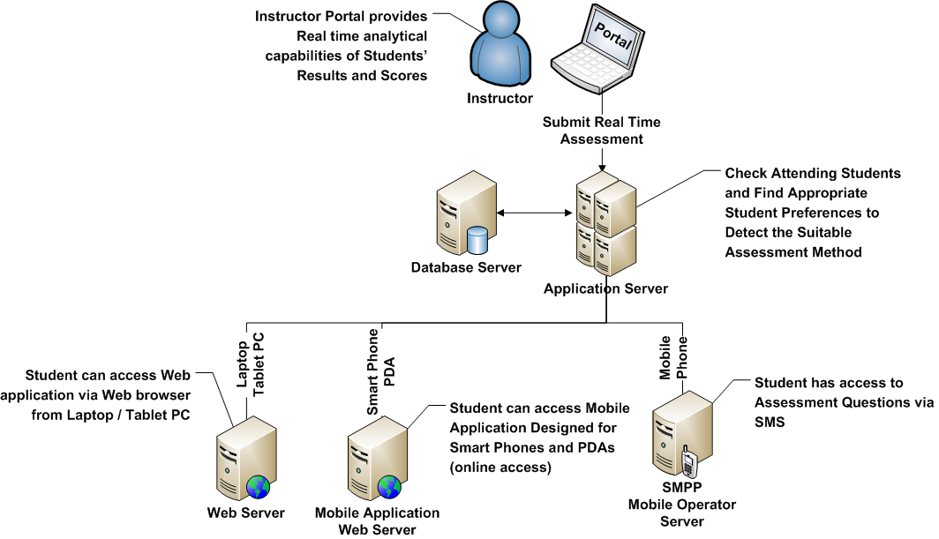
Figure 7: Proposed needed Applications to satisfy Proposed Adaptive Lecture Model functions
Software architecture mainly defines applications required to support adaptive lecture functionalities. Figure 7 presents applications required to support feedback process. Figure 7 presents and defines several types of servers and components required to support the adaptive lecture model. Mobile assessment utilizes new mobile services architecture to deliver interactive messaging automatically to send assessment questions and receive multiple responses Short Messaging Services (SMS). SMS responses should be integrated within LMSs to enable M-learning. Learner is connected to her/his mobile service provider via cell/smart phones. Mobile operators implement one or more SMS centers. Those are centers that manage sending and receiving of SMSs. University needs a mediator in the way to SMS center. Mediator connects directly to different SMS centers using Short-Message Peer-to-Peer (SMPP) protocol. SMPP is a telecommunication industry protocol for exchanging SMS messages between SMS peer entities such as SMS center. It is often used to allow third parties to submit messages in bulk. SMPP has been designed to offer services for various cellular networks such as GSM, CDMA, and TDMA (Henry-Labordere and Vincent 2004). Mediator is connected directly the University server over the internet, via standard Web services. Via SOAP request, university can receive SMSs aimed to it, and via SOAP response, university can send new SMSs. University LMS should manage sessions with different users, utilizes data within SMSs in managing learners profiles.
4.3 INFORMATION ARCHITECTURE TO SUPPORT PROPOSED ADAPTIVE LECTURE MODEL
Information Architecture is about Organising functionality and content into a structure that people are able to navigate intuitively. If Organisations didn't recognise the importance of information architecture, they run the risk of creating great content and functionality that no one can ever find. Information architecture is the term used to describe the structure of a system, i.e the way information is grouped, the navigation methods and terminology used within the system. An effective information architecture enables people to step logically through a system confident they are getting closer to the information they require. Information architecture is most commonly associated with websites and intranets, but it can be used in the context of any information structures or computer systems (Barker , 2005).
Information Architecture plays an important role in the Web 2.0 era. Amount of information became available online is tremendous. Everyone has become a participant in the generation of content. Proposed Adaptive Lecture Model tends to make use of the Web 2.0 technologies, and thus Information System that supports it is expected to deal with a large amount of real-time, changing, and updated data. Information Architecture is necessary to keep and maintain the logic behind the supportive applications for the Proposed Adaptive Lecture Model. Applications need to provide Web 2.0 functionalities, in a way that doesn't distract students during lecture; as much as possible. Instructors need to view analysis results and reports during the lecture without leaving the interface they use for teaching. Proposed Adaptive Lecture Model Information Architecture needs to address:
- Instructor Portal: That Instructor uses to launch required tools to enable lecture activities; like sharing files, desktop activities, initiating quizzes, and other activities. Also, this portal shall enable instructors to initiate and manage after-lecture activities; like assignments and workspaces.
- Student Portal: That studens use to access different aspects of the lecture activities, besides the after-lecture activities.

Proposed Adaptive Lecture Model utilizes different technologies as presented. It is important to present portals that provide those different functionalities without loosing the users' aim. Web 2.0 Technologies include Widgets/Gadgets presented in previous paragraphs. Different Widgets can be embedded in the Portal to provide the required functionalities on different sites without leaving the portal. However, widgets are challenged by limited capabilities and features. It is not an easy task for the Information Architect to maintain. Challenges will rise during architecting the portals.
4.4 INFRA STRUCTURE (IT) ARCHITECTURE TO SUPPORT PROPOSED ADAPTIVE LECTURE MODEL
The IT architecture defines the hardware and software building blocks that make up the overall information system of the organization (Albin, 2003). IT architecture includes hardware and software infrastructure including database and middleware technologies. The IT architecture should enable achievement of the business goals using a software infrastructure that supports the procurement, development, and deployment of core mission-critical business applications. The purpose of the IT architecture is to enable a company to manage its IT investment in a way that meets its business needs by providing a foundation upon which data and application architectures can be built. Figure 8 highlights a required IT infrastructure in the learning institution to support proposed adaptive lecture model. Most universities are already taking large steps in deploying infrastructure enhancements to their classrooms.
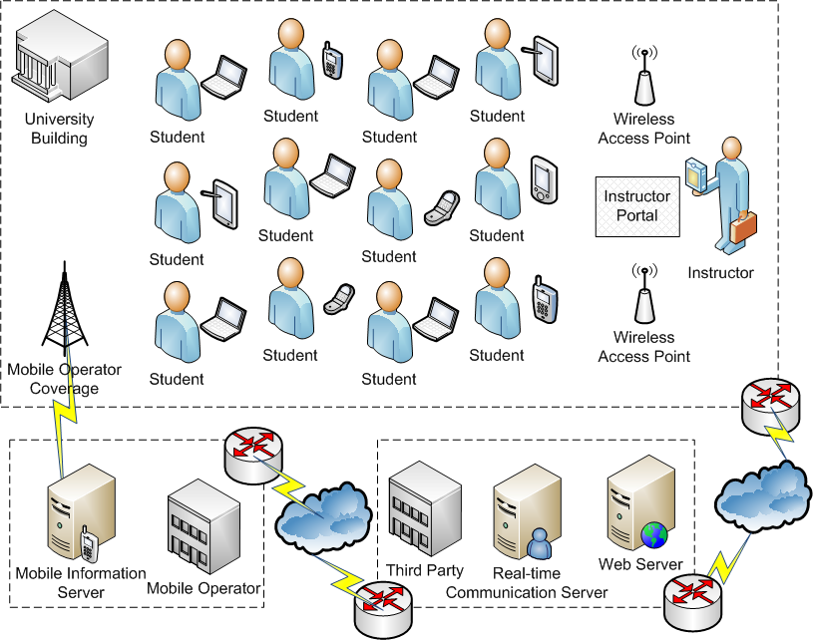
Figure 8:Proposed Adaptive Lecture IT Infrastructure

Figure 9 presents a proposed IT architecture to support proposed adaptive online lecture model. Educational institutions differentiate between different components required to support the learning process, and are familiar with some technologies like UMIS and LMS. IT Architecture includes the following servers list:
- Firewall: The system’s entry point and responsible for providing security functions.
- Active Directory (LDAP): A Single Log-in point for the entire system. Helps avoid the repeated Log-in process between different applications and servers.
- Collaboration, Assessments, and Assignments: Main components of the Learning Process that are maintained separately to provide greater flexibility and the ability to utilize different technologies.
- Students Data, Student Preferences, Learning Profiles: Main asset of LMS that maintains students’ data to be utilized by different applications. Adaptive Online Lecture Model relies heavily on those data to present personalized recommendations.
- Course Specifications and Instructors Data: Data about Instructors and Courses are stored to enable automation of the communications between Course Management Systems (CMSs) and Recommenders.
- Real-time Communication Server: Responsible for providing communications functionalities between instructors and students, and students and each other. Manages Online Lecture file, desktop, text sharing, other activities, and Web 2.0 technologies that will be utilized in the Informal Feedback.
- Analyzer and Report Generator: Responsible for analyzing gathered data and generating Reports that are used by instructor to identify the sequence of lecture activities, students’ learning profiles and preferences, and feedback activities.
- Middleware: Responsible for managing Quality of Service (QoS) and directing messages between different components of the systems.
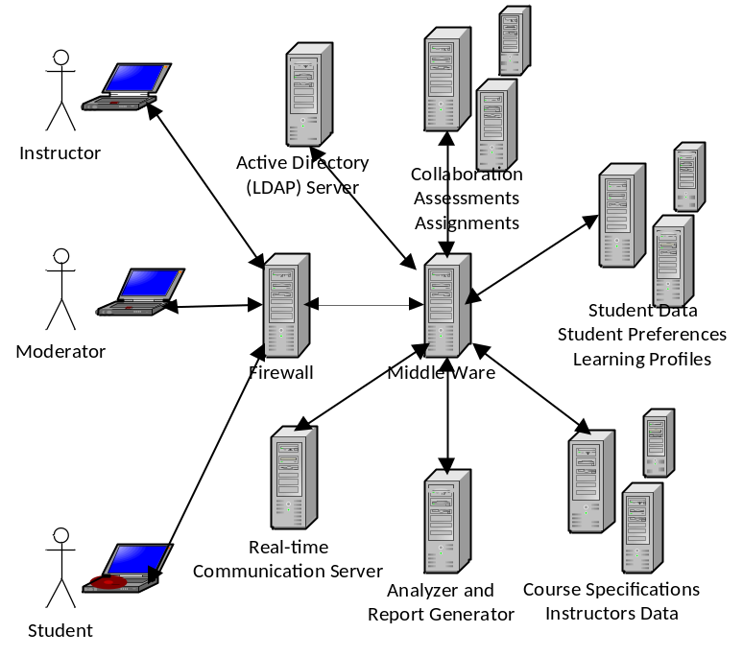
Figure 9: Proposed Adaptive Online Lecture Model IT Architecture
Cloud Computing is an emerging IT technology that will be utilized in different innovative ways in learning institutions. Cloud Computing is a large-scale distributed computing paradigm that is driven by economies of scale, in which a pool of abstracted, virtualized, dynamically-scalable, managed computing power, storage, platforms, and services are delivered on demand to external customers over the Internet (Foster et al., 2009). Cloud Computing is a distributed computing paradigm that focuses on providing a wide range of users with distributed access to virtualized hardware and/or software infrastructure over the Internet. Drivers for Cloud Computing adoption include: scalability, elasticity, virtualization, cost, mobility, and risk reduction (Lewis, 2009).
5. INSTRUCTOR CHALLENGES AND EXPECTED OUTCOMES OF PROPOSED ADAPTIVE LECTURE MODEL
In e-Learning 2.0, instructors’ capabilities are challenged by new technologies. Instructors are more information related in the information age compared to the situation in the traditional model. It is not just that instructor needs to be capable of utilizing different technologies to achieve the adaptive lecture model, it is their ability to prepare and manage different scenarios during the lecture, and utilizing different technologies made available to their students. Instructors are challenged by the involvement levels with students. Online access and facilities opened new ways for students to communicate with their instructors, and forced instructors to present minimum level of online support that entitles collaboration and communication activities that wasn’t a necessity before. Students’ interactivity and engagement in the learning process are expected to increase. Students’ awareness of new technologies and their utilization in useful learning experiences hopefully will make new opportunities for new generations to use new technologies in a productive manner.

6. CONCLUSION
Adaptive Lectures are lectures that present the capability to continuously get personalized and enhanced based on students’ feedback. Adaptive Lectures can make use of widely presented Web 2.0 technologies in enhancing the lecture, via presenting enormous verities of feedback generation mechanisms and enhancing collaboration. Adaptive Lectures can also be empowered by the utilization of intelligent techniques that enhances the analysis of students’ profiles and learning preferences for sake of defining the most appropriate and suitable learning scenarios and environments for students. This paper presented proposed pedagogical features of Adaptive Lecture Model; a model that enhances the current lecture model, and proposed modifications for current University architecture to adopt proposed adaptive lecture model. University Architecture was discussed from four dimensions: Business, Software, Information, and IT Infrastructure.
REFERENCES
Albin, S. T. (2003). The Art of Software Architecture: Design Methods and Techniques, John Wiley & Sons, 2003.
Arab Knowledge Report 2009: Towards Productive Intercommunication for Knowledge, (2009). Mohammed bin Rashid Al Maktoum Foundation (MBRF) and the United Nations Development Programme/ Regional Bureau for Arab States (UNDP/RBAS). Retrieved November 11, 2009 from http://www.mbrfoundation.ae/English/pages/AKR2009.aspx
Baskerville, R. (2005). Business Agility and Information Technology Diffusion, Springer.
Bechara, G. (2006). An Introduction to Enterprise Architecture, Oracle, Archived Article - Originally published on BEA Arch2Arch March 2006, http://www.oracle.com/technology/pub/articles/dev2arch/2006/03/enterprise-architecture.html
Black, P. & Wiliam, D. (1998). Inside the Black Box, London : King's College.
Bloom, B.S. (1984). The 2 Sigma Problem: The search for methods of group instruction as effective as one-to-one tutoring. Educational Researcher, v13, n6, pp4-16.
Chang, J. F. (2005). Business Process Management Systems: Strategy and Implementation, AUERBACH.
de Putte, G.V.; Benedetti, T.; Gagic, D.; Gersak, P.; Krutzler, K.; Perry, M. (2001). Intra-Enterprise Business Process Management. IBM Redbooks..
Earl, L. (2003). Assessment As Learning: Using Classroom Assessment to Maximize Student Learning, Corwin Press.
El-Ghareeb, H. A. (2009). E-Learning and Management Information Systems: Universities Need Both. eLearn Magazine, ACM, Retrieved October 28, 2009 from http://elearnmag.org/subpage.cfm?section=articles&article=96-1
El-Ghareeb, H. A. (2010). Learning Institutions Convergence into e-Learning 2.0 via Web 2.0 Technologies. Technology for Creativity and Innovation: Tools, Techniques, and Applications. IGI Global. Under Publication.
Ellis, A. (2001). Teaching, Learning, and Assessment Together: The Reflective Classroom, Eye on Education.
Evans, N. (2001). Business Agility: Strategies for Gaining Competitive Advantage Through Mobile Business Solutions, Prentice Hall.
Ferretti, S.; Mirri, S.; Muratori, L. A.; Roccetti, M.; Salomoni, P. (2008). E-learning 2.0: you are We-LCoME!. Proceedings of the 2008 international cross-disciplinary conference on web accessibility (W4A). ACM International Conference Proceedings Series; Vol. 317.
Foster, I.; Zhau, Y. ; Ioan, R.; and Lu, S. (2008). Cloud Computing and Grid Computing: 360-Degree Compared. Grid Computing Environments Workshop.
Grosseck, G. (2009). To use or not to use web 2.0 in higher education? World Conference on Educational Sciences, - New Trends and Issues in Educational Sciences. Volume 1, Issue 1, El-Sevier, Nicosia, North Cyprus.
HA, R. (2005). Process Design and Redesign, chap 9. In: Process Aware information Systems, Dumas et al., Wiley.
Henderson, A. (2003). The E-Learning Question and Answer Book: A Survival Guide for Trainers and Business Managers”, AMACOM/American Management Association.
Hohmann, L. (2003). Beyond Software Architecture: Creating and Sustaining Winning Solutions, Addison Wesley.
Krathwohl, D. R. (2002). A Revision of Bloom’s Taxonomy: An Overview. Theory Into Practice, Volume 41, Number 4. College of Education, The Ohio State University
Leidner, D.; R. Beatty, R.; Mackay, J. (2003). How CIOs Manage IT During Economic Decline: Surviving and Thriving Amid Uncertainty, MIS Quarterly Executive, 2003, Vol. 2.
Lewis, G. A. (2009). Cloud Computing. SEI Webinar, Carnegie Mellon University
Macaulay, A. (2004). Enterprise Architecture Design and the Integrated Architecture Framework, Microsoft Architects Journal. Vol. 1, pp. 4-9.
MAY, M. (2003). Business Process Management: Integration in a Web-enabled environment. Prentice Hall.
Moursund, D. G. (2005). Introduction to Information and Communication Technology in Education. University of Oregon. Retrieved November 2009 from http://hdl.handle.net/1794/3181
Pal, N.; D. Pantaleo, D. (2005). The Agile Enterprise: Reinventing Your Organization for Success in an on Demand World, Springer.
Pollock, J. T. (2009). Semantic Web for Dummies. Wiley Publishing Inc.
Sprott, D.; Wilkes, L. (2004). Understanding Service Oriented Architecture",Microsoft Architect Journal, Vol. 1, pp. 10-17
The 2009 21-st Century Campus Report, (2009). CDW-G. Retrieved November 12, 2009 from http://webobjects.cdw.com/webobjects/media/pdf/Newsroom/CDWG-21st-Century-Campus-1009.pdf

